NEWS DESK ARTICLE ADDING TUTORIAL

- Go to http://www.fau.edu/newsdesk/.

- At the very bottom of the webpage, look for the © and click on it.

- On the next page when prompted, use your FAUNet ID to log in (Note: Only those with appropriate access will be granted permission to edit the News Desk site.)

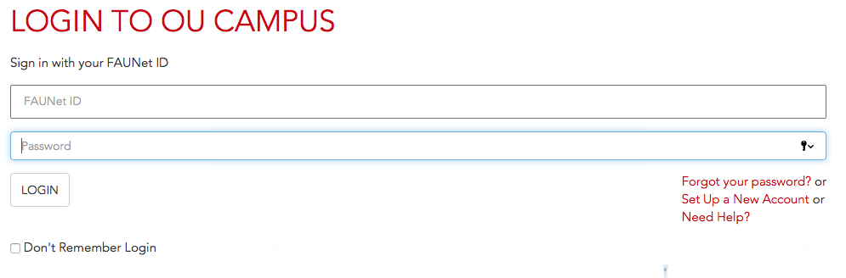

- After logging in, click on Back to Pages in the top left corner of the site.
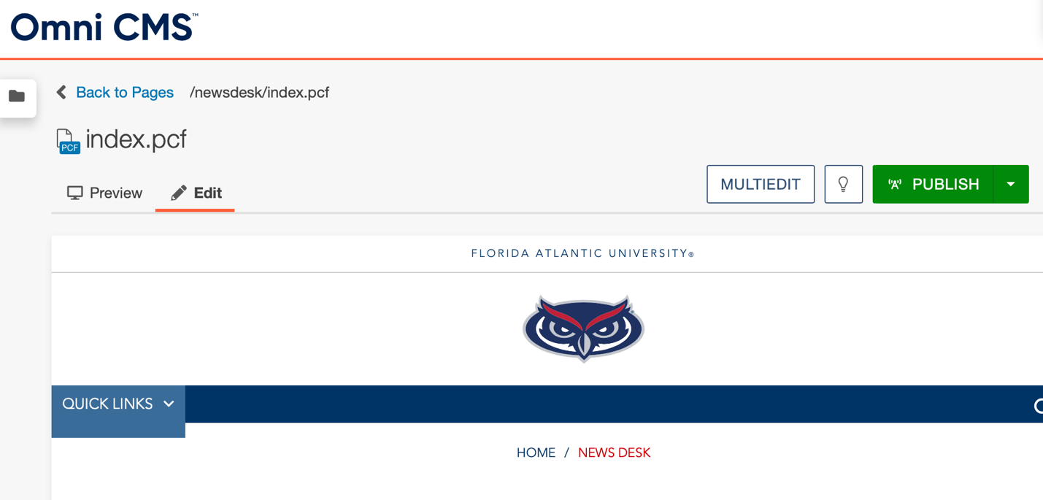

- Clicking on Back to Pages will lead you to the Pages files site where you select the articles folder.

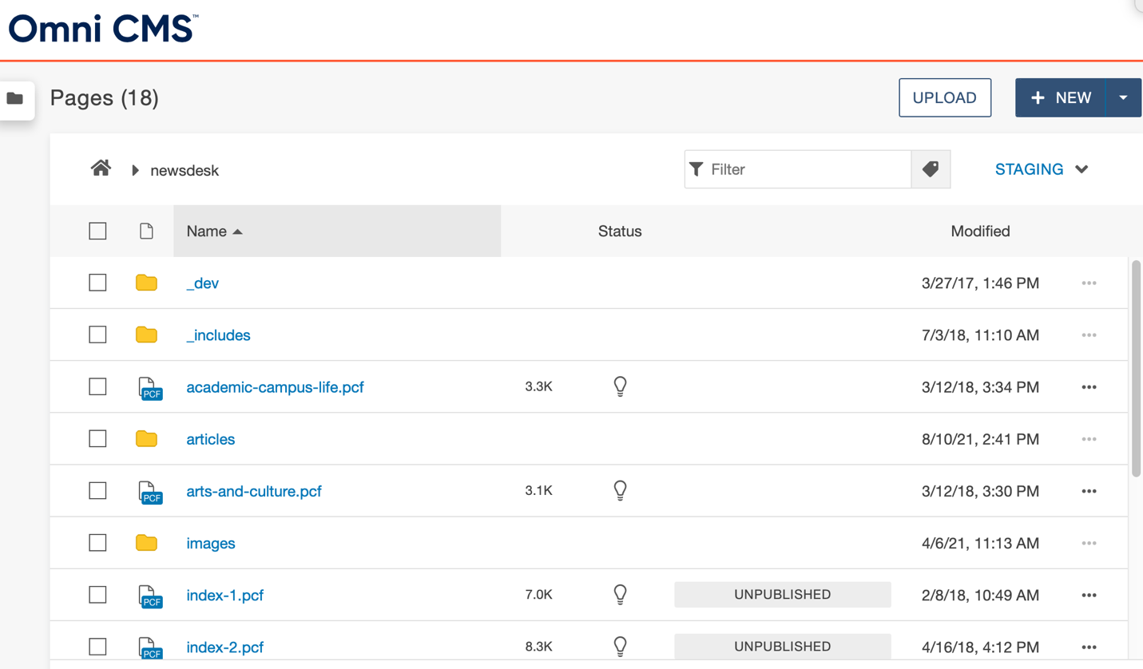

- Clicking on the articles folder will lead you to the page that contains all News Desk articles within the site.

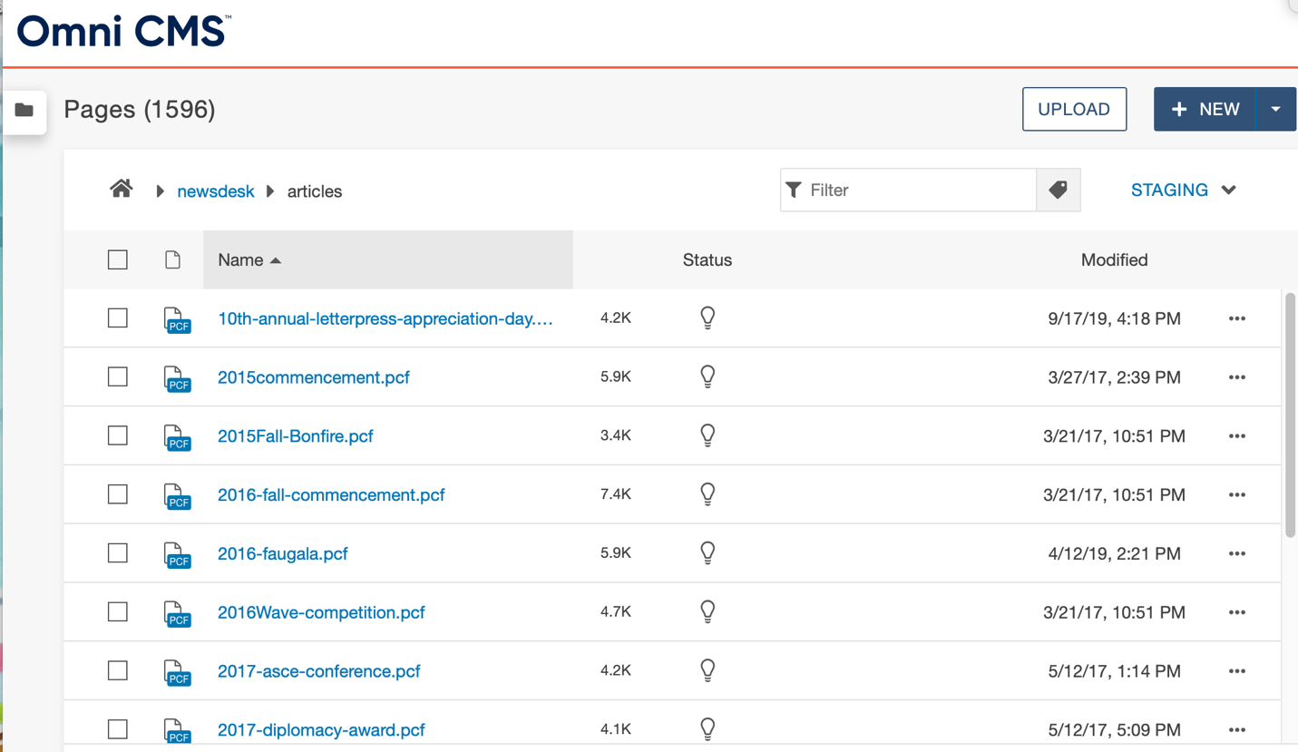

- Once on the articles page, click the green button that says +New. A New Content pop up will appear, click on Newsdesk Article.
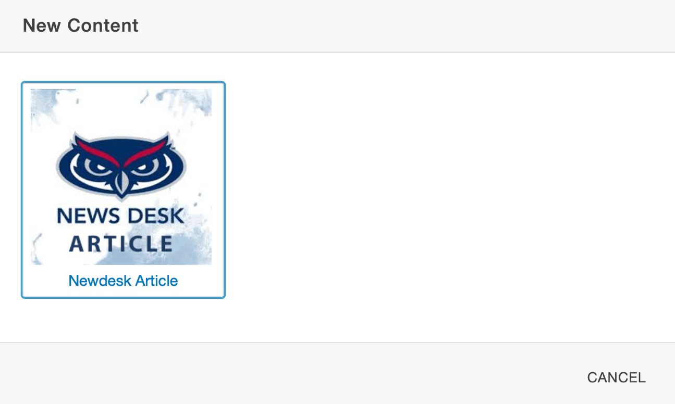
- After selecting Newsdesk Article, a New Page pop up will appear. This is where you input contact for a new News Desk story/press release posting.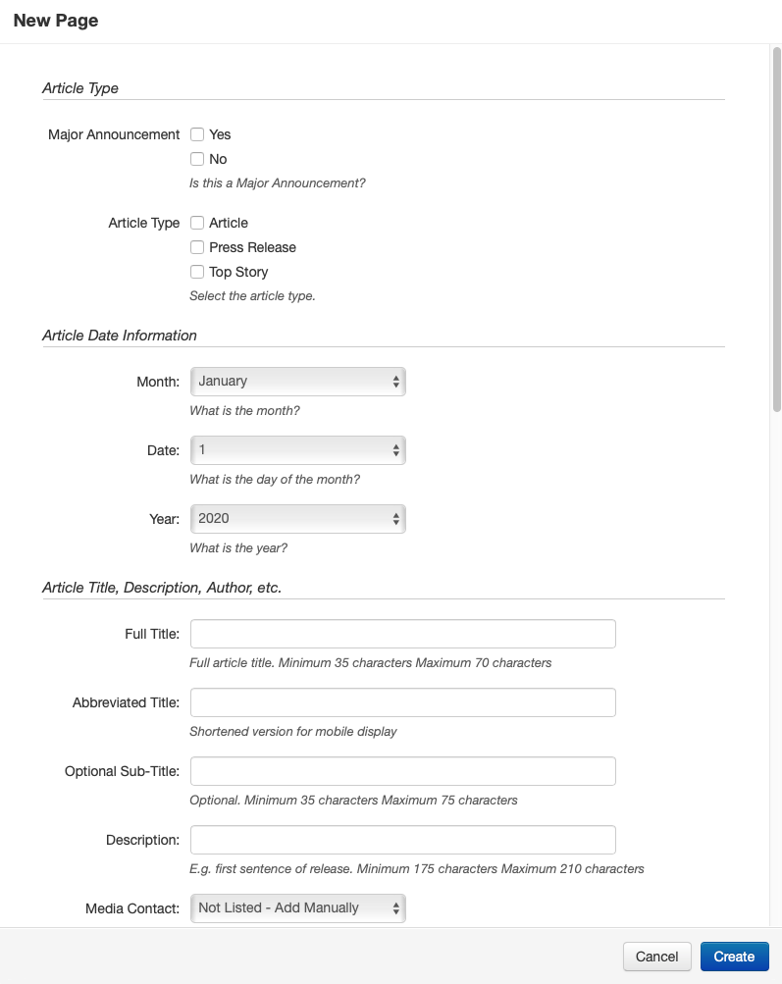

- – Check the appropriate boxes for whether it’s a Major Announcement or the Article Type.
- Select the date you are posting the story as the Article Date.
- Full Title and Abbreviated Title should be the same (Note: maximum 60 characters).
- Do not enter an Optional Sub-Title.
- Enter in Description information (Note: often times this is the first line of the story/release.)
- Select your name for Media Contact.

- Make sure to have an image ready and sized to 975 x 650. Under Large Image click on the paper icon and a Choose a File pop up will appear.

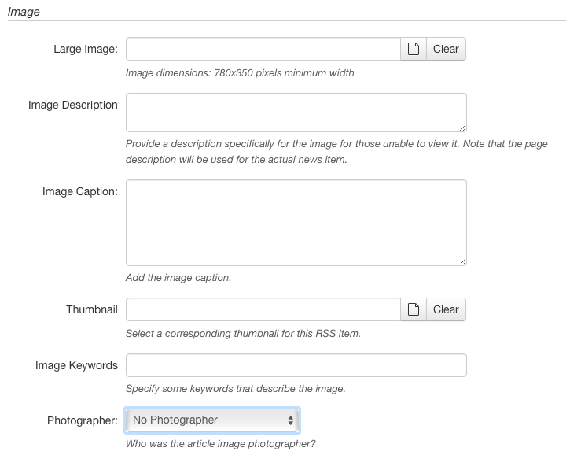

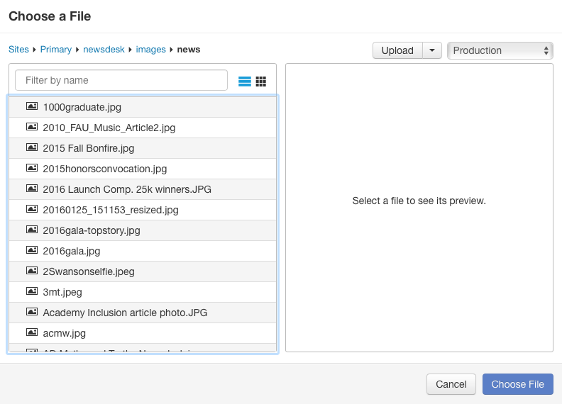

- Click the Upload box and an Upload to /newsdesk/images/news pop up will appear. Click on the green button that says +Add to upload a new image. Select the file on your computer and click Start Upload. Once the image is uploaded, click the blue button that says Choose File.

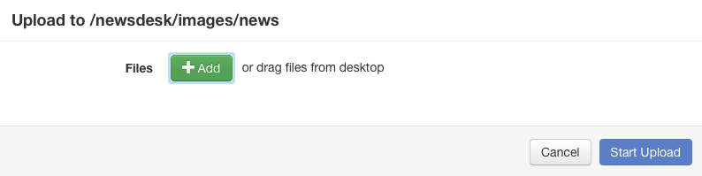

- Fill in the Image Description and Image Caption sections.

- For the Thumbnail section, click on the paper icon and select the same image you uploaded for the Large Image section (Note: you DO NOT need to re-upload the image.)

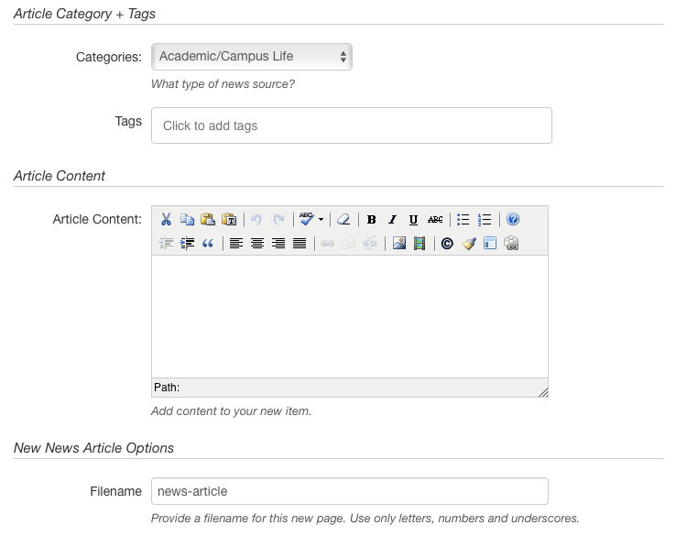

- Under Categories, select the corresponding category in the drop down for the story/release.

- Under Tags, add any corresponding Tags that relate to the story/release.

- In the Article Content section, copy and paste only the body of the story/release. This is also where hyperlinking should be done in the story if there’s not already hyperlinks (Note: DO NOT copy and paste any title or boiler plate info in this section.)

- Under Filename, shorten the title or use any key words, this will be what appears in the website link. (Note: Capital letters are not permitted and spacing should include “–“ between words.)

- Once complete, click the blue button that says Create.

- After you click Create, the next page will give an example of what the story/release will look like on the News Desk. Make sure that everything is correct and click the green button at the bottom right of the page that says Publish.

- Once published, View Story in New Window will appear at the bottom that will give you an indication that the story has been successfully uploaded to the News Desk website.

- Your story should now be available at http://www.fau.edu/newsdesk/. If the story doesn’t immediate appear, please refresh your browser.

